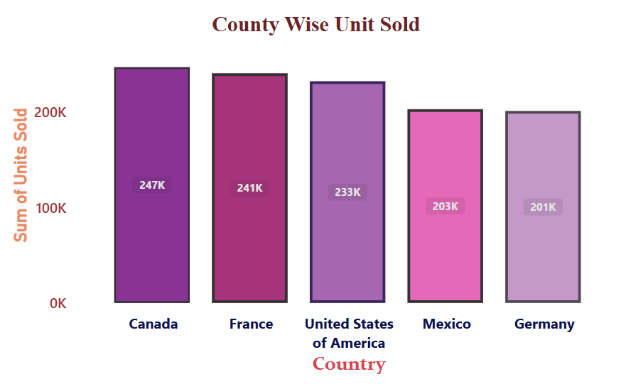

Country Wise Unit Sold

**Steps:**

* **In Report View Tab**

1. Visualizations tab ->Build Visual
2. Click on **Stacked Column Chart**

* **Data Tab**

1. **Financials** -> Select Column name according to the given question

* **Build Visual**

1. X-axis -> Country
2. Y-axis -> Unit Sold (sum)

* **Format Visual**

1. Format Visual -> visual

* **X-Axis:**
* **Values**
* Font -> Segoe UI Bold
* Size ->24, Bold
* Color -> Navy
* **Title**
* Title Text -> Country
* Style -> Show Title Only
* Font -> Constantia
* Color ->Orange
* **Y-Axis:**
* **Range** ->Min=50000, Max=3,00,000
* Display Units -> Thousand
* **Values**
* Font -> Segoe UI Bold
* Size ->12, Bold
* Color -> Brown

* **Title**
* Title Text -> Auto
* Style -> Show Title Only
* Font -> DIN
* Color -> Orange
* **Gridlines:**
* Horizontal -> **OFF**
* **Columns:**
* Categories (color): Theme Color 1
* Canada ->20% Lighter
* France ->25% Darker
* USA ->40% Lighter
* Mexico ->40% Lighter
* Germany ->60% Lighter
* **Border:**
* ON
* Color -> Black
* Transparency -> 6%
* Width ->5px (for all)
* **Data Labels:(ON)**
* Options:
* Orientation ->Horizontal
* Position ->Inside Center
* **Format Visual**
* Format Visual ->**General**
* Title -> Text -> Country Wise Unit Sold
* Heading ->Heading 3
* Font ->Times New Roman
* Size ->18, Bold
* Color -> Brown
* Horizontal Alignment -> Center